www.enoughtrace.com 650 299-9927 (h) 415 699-6462 (m) vkhachad@yahoo.com

Deliberately inactive on LinkedIn – My lawyer’s demand: Stay away from social media

I’m done working for project managers who use Red, Orange and Green.
Gave up $15 million in hush money from Oracle to write this resume.

I will not grant any interviews to parties who have not read my entire resume and have not spent serious time studying the contents of my website. I know that a resume should be 2 pages. I know how to write a “Good” resume. This issue deserves all 12 pages, with innocent people sitting in jails and unfairly being killed in TESLA cars or Oracle failures and Boeing 787 crashes like the Air India 171 example, possibly caused by software. I will not allow any modifications to this resume. The first 7 pages are about my context-based, AI discovery.

If you are reading the pdf version of this resume, then you will not be able to click on its links to verify the evidence. The MS-Word copy of this CV is in the Resume/References link on my website: www.enoughtrace.com

In this 2024 Youtube clip, the CEO of nVidia, Jensen Huang, and the famous AI expert Ilya Sutskever of OpenAI, discuss the challenge of different contexts in which the word “Great” can appear in a sentence. Forward to 4:00.

https://www.youtube.com/watch?v=y1AxIpIaQmI&ab

Huang and Sutskever are trying to solve this problem in Large Language Models (LLMs), where a mistake produces only a funny sentence. I discovered and solved this problem in 1996, where every minute was worth millions of production dollars on real cases, not test.

This is an excerpt from my wrongful termination lawsuit against Oracle in February 2011. My hero attorney, Bill Guffey wrote this about context in the complaint in 3 days. Forgive his typos:

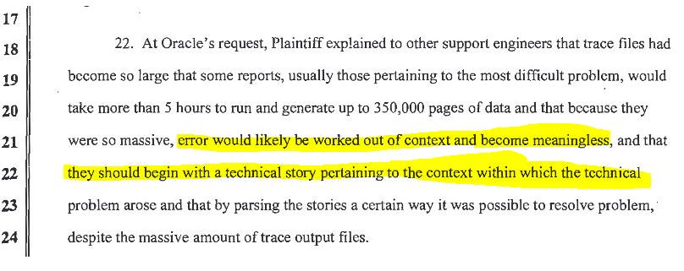

A penniless gig worker, with a math degree from U.C. Berkeley, blacklisted for solving one of the biggest challenges in Artificial Intelligence at Oracle. The problem spilled over to TESLA Driving software, OpenAI’s ChatGPT, Google, GM Robotaxis and Boeing airplanes, where automation sadly took over from pilots and crashed 2 planes. Massive amounts of data, from different sources, need to be processed in context; otherwise, you’ll end up in disaster. Created Data Storytelling to solve 400 of the toughest cases with 100% success, with real production pressure at Oracle, since 1996.

I didn’t accomplish all this in a research lab with play data, where deadlines can be postponed and futuristic papers can be written. Didn’t save “Humanity”, like Elon Musk. Wasn’t conflicted between success and “Destroying humanity”, like the current AI players are screaming about. They used my success as a Proof of Concept and have been failing, since 1996. Customer production systems were down. Every minute was worth millions. Stayed at Escalation Database Support - 15 years. Facing the battleground heat. The data I succeeded with was real production data, with real consequences.

Technically led at least 400 customer DBA teams when they were having their toughest crises. Was the high level architect, also the hands on, lowest level weed-puller, mentoring over 100 Support engineers and over 2,000 customers. My success rate: 100%.

During the TESLA quarterly earnings call on October 23, 2024, Elon Musk said the following about his company’s failure to achieve Full Self Driving (FSD), even though he promised to deliver FSD in 2016:

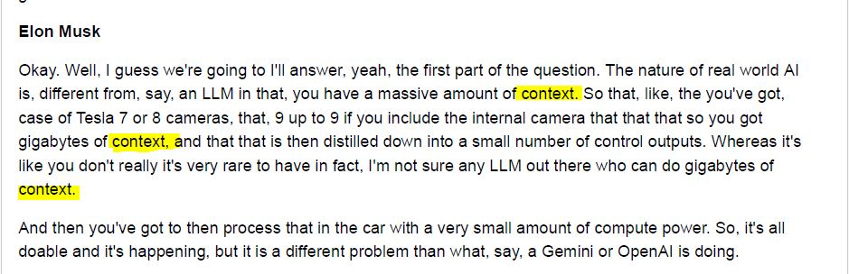
Elon conceded that collecting data from 8 cameras poses the challenge of processing all that data in context. He also conceded that he does not have the problem solved. I discovered that problem in 1996 at Oracle, when Oracle’s trace files were producing diagnostic content from many layers of Oracle’s code, when the data was being processed without context. Even the smartest Oracle developers were taking months to come up with 15 minute solutions. With this discovery, in my capacity as an Oracle Database Support Rep, I solved 400 of the toughest cases with 100% success.
In TESLA’s case, the data from the 8 cameras have to be processed in context to produce driving solutions every split second. In Oracle’s case, the massive amount of diag data had to be processed from the different parts of the Oracle code to produce the correct diagnostic decision. Distinctions, with no difference. This is a major challenge in all AI based processing today.
In her 2021 report to President Biden, 14 years late, Oracle’s CEO Safra Catz endorsed my discovery and 100% successful solution in Artificial Intelligence and Machine Learning. She said: The proper use of context will “discover rapid solutions to problems that would historically take years to examine”.
Elon Musk’s chances of success with his TESLA standard software is less than zero. In mid 2023, 7 years after promising Full Self Driving to the world, Elon Musk finally ditched his fatally flawed rules-based TESLA FSD and is now promoting a Network-Path-Based approach. Finally, he agreed with me to use technical stories to put AI data in context. Elon is 27 years late. For the sake of everyone involved, I wish him plenty of luck. I'm not holding my breath.

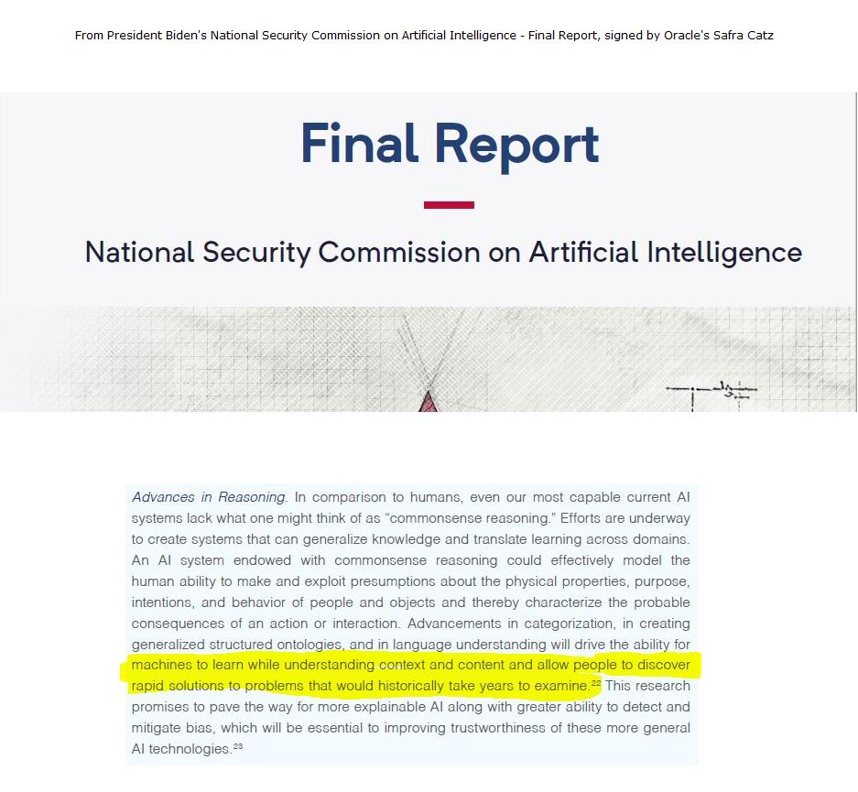

In 2023, Elon Musk started saying that without achieving some semblance of AGI (Artificial General Intelligence), which is supposed to match or exceed human intelligence, he cannot deliver Full Self Driving (FSD). Meaning that his promises for FSD in 2016 were unsupportable. Oracle’s Larry Ellison was on TESLA’s board, resigning in June 2022. A 2.5 year internal investigation proved that executives at Oracle knew that processing massive amounts of machine learning data without context will result in disaster. Oracle also knows of my 100% success, when I sifted through literally millions of lines of trace file content, from sometimes 1000’s of trace files, solving problems in lightning speed.

The image above is from Presidents Trump and Biden’s National Security Commission on Artificial Intelligence. Oracle’s CEO Safra Catz signed it in 2021. She and the Commission are 10 years late. Not a single one of them have matched my success. Safra Catz is 14 years late, because by 2007 Oracle knew about my discovery at executive levels. I wonder where she got the idea about the role of context. Could it be the 2.5 year context-investigation that Oracle conducted in 2005 – 2008? The commissioners have garnered the attention of the Secretaries of Defense, State and Commerce, as well as President Biden’s National Security Advisor, Jake Sullivan.

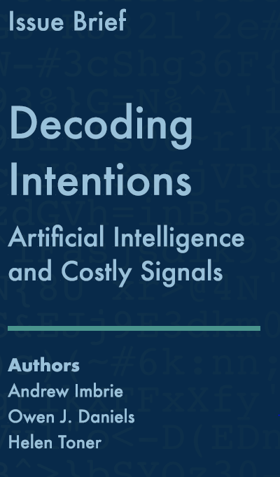
A month before firing ChatGPT’s CEO Sam Altman on Nov 17, 2023, one of its Board members, Helen Toner wrote a 66-page brief called: Decoding Intentions – Artificial Intelligence and Costly Signals.

Page 2 of the brief states:
“Compatible messaging from public and private sector leaders can enhance the credibility of commitments in AI, but officials may also misinterpret signals if they lack appropriate context for assessing capabilities across different technology areas. Policymakers should consider incorporating costly signals into tabletop exercises and focused dialogues with allies and competitor nations to clarify assumptions, mitigate the risks of escalation, and develop shared understandings around communication in times of crisis. Signals can be noisy, occasionally confusing some audiences, but they are still necessary.”
I discovered, championed and solved this problem of context-lacking noisy signals, which were confusing Oracle’s developers, Support engineers and customers.

In their 2021 book, “The Age of AI and Our Human Future”, Henry Kissinger, Eric Schmidt and Dan Huttenlocher of MIT, state on page 52 that “information is not self-explanatory, it is context-dependent…When information is contextualized, it becomes knowledge.” Exactly right, since 1996.

In the past, computers sent us our monthly banking, phone, energy statements, insurance bills, etc., but after 2010 for sure, they started taking over our actions like driving or flying commercial airplanes. Before all of that, by the mid-90’s, Oracle was considered the de facto database for mission critical applications. Oracle’s goal was to keep its databases up 24x7. Oracle greatly enhanced its diagnostics and system monitoring tools, embedding them in every function. Data started being processed from many layers of the code, all at the same time, coming to technicians in trace files the same way. That’s when I discovered how massive amounts of data, being processed without context will result in disaster. Oracle eventually agreed with me, but they are light-years away from matching my success.
The failures in TESLAs and Boeing 737, 777, etc., Israeli Intelligence, are the same. They are collecting data from different sources all at the same second, then making split-second decisions. In Oracle’s case the offense is worse. In addition to the software miscalculating, customer DBA’s, Oracle’s support reps and developers are getting lost, even after personally studying the diags. Human judgment and common sense is being destroyed. In the TESLA Driving software or Boeing, the software may not be giving the operator any chance. The damages are severe, people die.
One of the worst episodes of this failure happened when Israel, which is considered to be in the top three countries that utilize Artificial Intelligence, and has garnered praise about how they use AI for national security, completely missed the threat they were facing from Hamas. According to the New York Times, for weeks and months their AI systems led them to wrong conclusions.

To understand context better, read the 1-page description of Former President of Stanford University, Dr. Donald Kennedy’s analogy on my website.
After I uploaded my resume to the job website indeed.com, it immediately started sending me emails, telling me the following:
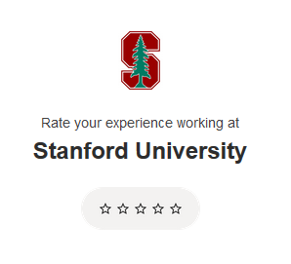

This is a good example of machine learning data being processed out-of-context. I never attended or worked at Stanford. A mistake like this in resume-reading is no big deal. A mistake like this in a TESLA driving internals will kill people. A mistake like this in a Boeing MCAS (Maneuvering Characteristics Augmentation System) will crash airplanes. Mistakes like these have been taking place in Oracle’s product since 1996. My success rate since 1996: 100%.

In January 2023, in Davos Switzerland, at the World Economic Forum, the Director of the FBI, Christopher Wray said the following:

"One of them is the danger that there could be ways to confuse or distort the algorithms to cause physical harm, I’m thinking about a story I heard not that long ago about the researchers who were able to trick a self-driving car’s algorithm by essentially putting a piece of black tape over a stop sign. It caused the car to accelerate, about 50 miles an hour or something.
"It’s a simple example, but it shows some of the harms we have to guard against,"
"A different kind of harm we’re concerned about is the enormous amount of data that autonomous vehicles, for example, aggregate. And anytime you aggregate lots and lots of sensitive data, it makes a very tempting target.”

In his book called Digital Transformation, published in 2019, one of the high tech giants, Tom Siebel, my VP at Oracle and my CEO at GAIN Technologies (1989–92) says the following on page 78, Ch 5:

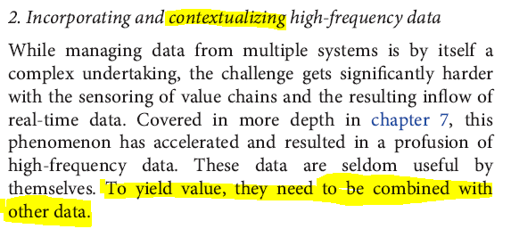
Exactly right, except that I discovered this problem in 1996, and solved it with 100% success. I satisfied the combining of data with other data by demanding that all engineers who came to me, start with the technical story of the case. Elon is using nVidia GOU’s to analyze videos to mimic this success.

My question to Tom is: How do you allow potentially innocent TESLA drivers to take the blame, be unfairly jailed, for probable TESLA software failures, when we all know that TESLA is collecting and processing massive amounts of data, all at the same second, from multiple sources?

In April 2023, Oracle published a research report called: The Decision Dilemma. Oracle presents a conclusion that when massive amounts of data come to decision makers from diverse sources, it can cause confusion. It says that 70% of business leaders, globally, prefer robots to make decisions for them. Oracle is 23 years late in writing this research paper, and Oracle has been covering up a 100% success record in this area of computing, where every minute was worth millions of corporate and government production database dollars. I disagree with Oracle. Human judgment is still vital.

Click this link for the Google Search for the Decision Dilemma by Oracle results. Otherwise, the link in the paragraph above will send you to the Oracle report.
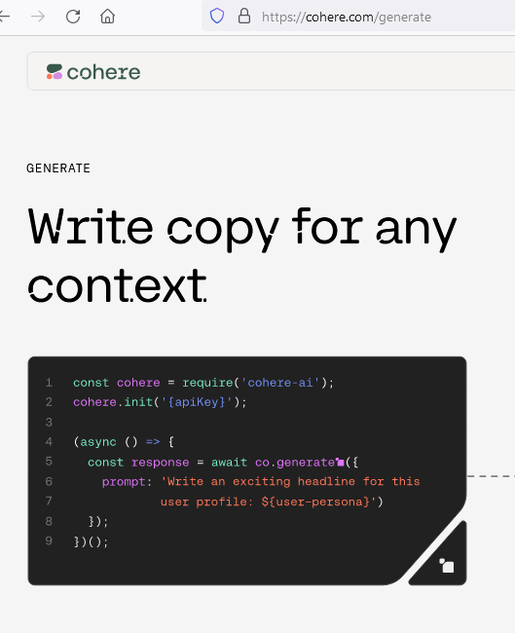
In June 2023, Oracle, Salesforce and nVidia announced that they funded an AI company called Cohere by $270 million. In early 2024, they increased the investment to $1 billion. One of the products of Cohere, talks about writing copy for any context. In March 2024 the investment grew to $5 billion. They are stuck.

This means that after firing me, and after applying for more than 200 context-related patents, Oracle, with all of its in-house developers, who I consider to be the best in the world, is still not able to make progress on the discovery I made in 1996. I presented it as their loyal employee in 1996, with my standard salary. They decided to fire me and finish it. So far, no solution.
The world saw what happened in Israel in October 2023, when robots took over and made security decisions.
In Spring of 2023, this Youtube clip from IBM Technology, at 5:30 into the video explains that without context, the Large Language Model will hallucinate, if context is not brought in to play its proper role. This video from IBM is 27 years late compared to my discovery in 1996. Their suggestion that the question has to have more specificity and context will not work. Writing code will be more accurate. More specific questions will take the shape of the legal fine-print we see in contracts. Our courts are full of disputes for misunderstanding paragraphs. Code is a lot more precise than long paragraphs.

That’s not what I did to succeed at Oracle. Sorry IBM.
https://www.youtube.com/watch?v=cfqtFvWOfg0&ab_

- In 2017, Larry Ellison finally agreed with my approach, officially, and labeled it as the biggest change to Oracle since the company’s founding. I have no patent dispute with Oracle.
- After leaving Oracle, in a few weeks, I saved a $450 million / year company called Southwest Traders from going under from a disastrous Oracle EBS implementation. Saved 850 jobs. See their president’s letter on my website (Acknowledgements - 1).
- When I was there in 2011, their damages were $13 million. A crooked lawyer got paid by Oracle and kicked me out. I had stabilized their system for 6 weeks. A baseline they threw away. After firing me, in 2012 and 2013, their damages grew to $116 million and $233 million respectively. See the Acknowledgements link (4) on my website for evidence. Los Angeles Superior Court Case BC506710, Stanley Mosk Courthouse.
I sued that lawyer, Arthur Charchian. Los Angeles Superior Court Case BC536326 – Stanley Mosk Courthouse. Won in 2017. His own witness said under oath that I was worth $200 / hr. The witness had a 30% share of the $400 million failure (my website).
After firing me, they collaborated closely with Oracle to save the system. They brought in a company called Trevera and spent $17 for every $1 they gave me. They failed and ended up throwing Oracle out. Trevera should have called me. Hundreds of people lost their jobs.

- Sent an 80-page report to the Attorney General of Oregon on why the $300 million, Cover Oregon project failed. She sued Oracle for criminal fraud, but with much lesser charges. She blamed Oracle’s employees, but shoved the evidence of systemic failures under the rug. Oracle paid the State of Oregon $100 million. She got reelected. Oracle’s powerful.
- Sent evidence to 2 people who closely knew Presidents Clinton, Bush and Obama. They were under criminal investigations by both the FBI and the State prosecutors. Explained why their $300 million Oracle project failure was not their fault. They were exonerated within weeks.
In February 2018 I met one of those 2 people, alone for 2 hours. The person gave me a hug and called me a hero. It feels good to save innocent people.
- My discovery is the real reason why Oracle’s revenues and profits have not grown since 2013. Across the entire Oracle customer base, many projects that need to grow are years behind schedule and millions over budget. Larry Ellison stepped down in 2014 to solve it. He’s still failing. Customers keep flipping DBA’s and developers on projects. Oracle is trying to grow revenues by instigating the TikTok ban and antitrust cases against Apple, Google and Amazon.

Chronological Highlights:

87- 2009: Database Support Rep at Oracle, Sales Rep and Manager of Sales Consulting.
5 years before Webex and many years before Zoom, before firewalls and the internet, my group used the Unix tee command to conduct online demo’s by asking for customers’ terminal ID’s, starting a new Unix shell and tee’ing the output of the shell to the customer’s terminal. In 1990, on 9,600 baud modems, on Oracle’s SUN Workstations, my group was conducting online, on-the-spot demos of the Oracle product anywhere in the world, supporting more than 60 Oracle salesreps. This initiative saved the company millions. The innovative idea was Valerie Lipman’s, my employee, not mine.
Remember, on Unix, standard input and output are treated as files.

95 – 2022: In 1996, after Oracle introduced the max_dump_file_size parameter, as an Oracle Database Support rep I discovered that Oracle’s trace files and parameters in the database code were being processed out-of-context. This is the root cause why many customers keep giving trace file after trace file on Service Requests to Oracle Support, with no solution after months of effort. Engineers don’t know which part of the trace file is relevant and which part is useless. I proved that relevance changes by context.
Started placing trace file content aside, evaluating them only after going over the technical stories of the customer. After reviewing everything from the metal to the user interface, solutions became obvious. Larry Ellison publicly agreed with this approach in 2017. Without my approach, Oracle developers would fix bug after bug, with no solution.

2005 - 09: Oracle conducted a 2 ½ year investigation, after which they concluded that I was right. My discovery proved that the problem was in every module of the product. The entire Oracle install base was being misdirected to rely on Oracle’s diagnostics in very harmful ways.
I looked at Oracle’s Multi-Cloud Observability and Management platform. They are finally adopting what I advocated in my emails during the investigation. They are claiming that the autonomous database is implementing it. I’m convinced they will fail, even though they are right in agreeing with me. They left my success unexamined. Oracle customers are vulnerable.

2007: Oracle made me the first one out of 4,600 support reps and developers to be a candidate for a patent involving Oracle’s diagnostics and context.
I have not pursued a patent battle with Oracle, and have no plans to do so. What I discovered then belonged to them. The VP’s who rejected it, hurt Oracle much worse than they hurt me. Oracle still employs them. Oracle demanded officially that I solve all problems with a single, 2-page patent. After firing me they applied for over 200 patents in that area of the product. It was a setup for me to fail. Larry Ellison is leading the effort. So far, no solution. From 1977 - 2007 Oracle produced at least 1 billion error messages and trace files in all its systems, but never applied for a single patent about error messages and context. Proof that my discovery had tremendous merit and proof that they ignored it, until 2007.
2011: Saved Southwest Traders (a $450 million / year company) from going under. Saved 850 jobs. Check the first 8 links in the acknowledgements section of my website.

Feb 2011: Sued Oracle in San Mateo County Court for wrongful termination about the faulty product.
My next attorney, Steve Ball, looked at my story and told me that the damages to Oracle’s customers are much higher than the damages to me. Advised me to withdraw the case. I did. See his email on my website.

Jun 2013: While still working for Kaiser as the SWAT Team Oracle DBA, had an in-person interview at Los Angeles Superior Court in downtown Los Angeles for their Oracle system. I had evidence about the California Court Case Management System losing $500 million on an Oracle / Deloitte project, which became a total loss, with proof about Oracle’s culpability. The interview was going very well until I showed them the evidence. The interviewers were Pratik Desai and Nikunj Gupta. Once they saw what I was presenting, they called in their manager. I don’t remember his name. After 10 minutes or so they escorted me out to the court hallway. I never heard from them again.
This happened 4 months before President Obama’s $1 billion healthcare.gov website and Oregon’s CoverOregon.com websites failed. Both on Oracle technology.
In March 2011, a recruiter called Ben Crosby contacted me right before I saved Southwest Traders. He told me about the California Court Case Management System, $500 million disaster. He wanted me to join them. I went with Southwest Traders and saved it.

2009 – 18: Held Oracle DBA, E-Business Suite (EBS), Enterprise Security, Sarbanes – Oxley and IT positions at Hitachi Consulting (EBS), Kaiser Permanente (SWAT Team for the Oracle Database), Kubisys, Union Bank (Enterprise Security), Aramark (EBS) and several others.
Technical Advisor for the Founder and CEO at Kubisys. Helped him with meetings and presentations for venture capital firms.
Informed very high ranking government officials about Oracle failures (DoD and DoJ). They took action. Maintained high credibility with them. When I’m seeing certain USDoJ actions, I’m confirming Oracle has powerful political influence.

2016: Several months after my start day, Union Bank gave me 3 hours to sign a new agreement. I was asked to give up the right to an attorney and designated Union Bank as my attorney, in case we had an intellectual property related dispute. I signed it under duress. I only had $6,000. I knew then that Oracle was desperate. I was doing useless work at Union Bank as far as IP went. My position was for database cyber security.
Couple of months later, they let me go. I’ve applied with them multiple times since then. They were not interested in my value. Only the exploitation of my value, to help Oracle.
If Union Bank ever tries to enforce this agreement, I’m pretty sure my attorneys and any government officials looking into my case will rip the agreement to shreds. TESLA drivers are dying and Oracle’s $16 billion Cerner Veteran’s Administration solution killed veterans. The failure of Israeli Intelligence is even bigger. GM’s self-driving Cruise cars were taken off the streets by The State of California, after they dragged a pedestrian under one of their cars for 20 feet. I accuse Union Bank of covering up Oracle’s criminally flawed software by this act.

2017: Larry Ellison finally agreed with me. At the September 2017 earnings call, he said:
“…and we are in the Cloud infrastructure business looking at network logs and operating system logs, and storage hardware logs, we are also looking at database logs, we are looking at people trying to log on to application systems and the passwords they are reducing…”
He finally agreed to place diag data in context of tech stack layers. Now he needs to help his friend Elon Musk stop killing people in his TESLAs, and stop making promises that Oracle’s top executives knew as early as 2007 that are not achievable.
Larry’s agreement was 21 years late. The damages to Oracle’s customers are in hundreds of billions of dollars. During the December 2019 quarterly earnings call, he labeled these changes as the most important Oracle product introduction since the company’s founding.

In September 2021, during the earnings conference call, Larry admitted that Oracle and Netsuite were pioneers in Cloud Computing. True. Oracle was at least 4 years ahead of AWS. This contradicts his statements in 2013 – 2017 when he kept explaining Oracle’s failures to increase revenues and profits as: Oracle’s transitioning to the Cloud. How did AWS beat Oracle, after being “4 years late to Oracle”? Larry knows or should have known. Oracle’s failure is happening because the flaw I discovered is in every function of the Oracle product. It did not raise error messages, so it was easy to dismiss and cover up. Oracle was more than 15 years late in addressing it. Then they dumped my 100% success rate, bought my lawyers and government officials.

Dec 2019: Imagine a 0.3 mile radius circle around my house. In that circle, my Blackberry Passport could send and receive text messages fine. Its internet access was fine. The connection bars were healthy and it gave notification that I got vmail. When I tried to make or receive phone calls, it said no communication, etc. All other phones in that circle worked fine. Once I got out of that circle, the Blackberry worked fine. I called the phone company and they escalated the case. No solution. I went to the police and showed them proof of my whistleblowing and that I had lengthy and multiple meetings with federal agents. They sent me to the FBI. I went to the FBI, they sent me to the police. I gave up. In a few weeks, the phone started working fine again. I made a video and posted it on Youtube. I drove in 5 directions and filmed it. It’s a 1-hour, boring video, but it documents the strange event.
Here is the link: https://www.youtube.com/watch?v=tmtED-gvNLY

2020: Right before COVID hit the USA, in Feb-Mar 2020, Google evaluated my resume and concluded that I’m a good fit as their $15 / hr Google-camera-car driver. I guess they saw no other value in me. Despite all the lawsuits that I had listed on my resume and website, they coasted me through hiring and on-boarding. Then they requested that I park the car in a location that was always visible from my home. I also learned that I could not talk on the phone while driving, even with Bluetooth or hands free. When I asked the onboarding team if the cameras in the car were going to be on 24x7, they said that the cameras were going to be on only when the car was driving. My question then was: Why should I park in a location that is visible from my house?
I concluded that hiring me was a scheme to keep an eye on me 24 x 7, for surveillance purposes. When HR departments and recruiters see my resume, they cannot run away fast enough. These guys wanted me, and wanted me with urgency.
I let Google hire me. I still have the airline ticket to fly from Los Angeles to Mountain View, CA to get trained, get their camera car and drive home. I declined their job offer by sending an email telling them I don’t want the job. It looked funny. A few days later I sent them an email telling them that I made a mistake, and that I wanted the job. They took me back right away. Usually when someone quits cold turkey like that on a $15 / HR job, without notice on day one, an employer will never take him back. These guys really wanted me. I quit again for the final time and never went back.
3 years later, on March 19, 2023, a Google Waymo self-driving car in San Francisco blocked an ambulance, when the ambulance driver tried to communicate with the remote Waymo employee to move the stationed car, another Waymo came and blocked the other side of the street. When you see an ambulance, stop, so it did. No problem.
By hiring me as their camera car driver Google could collect another benefit. As a blacklisted mathematician I had at least 250,000 in UBER driven miles with no accident. Observing my safe driving practices and collecting the data could give Waymo data that Google needed to make Waymo safer.
Google’s chance of success with their self-driving is less than zero and it’s getting worse. In April 2023, in his 60-Minutes interview about AI, Google’s CEO, Sundar Pichai said that Google’s AI engine hallucinates. He also said that the entire industry had no solution for it. If so, why is he putting hallucinating software in cars where people’s lives hang in the balance?
His statement that there is no solution is not correct. Thomas Kurian, the head of Google Cloud was the head of Oracle Cloud. Oracle has the record of my 100% success, which needs to be examined. So far they have failed to replicate it.

85 – 2002: A year before finishing my math degree at U.C. Berkeley, I got the contract to computer-
score San Francisco Marathon (1985). It was the 4th biggest marathon in the country, after New York, Boston and Honolulu. I was still at school and was tending bar on the side.
The industry used a timing device called Chronomix. It cost thousands of dollars. I replaced it with a Microsoft PASCAL program, which cost the price of the compiler, using the clock of my IBM-PC, running DOS 2.1. It had all the flexibility of software.
On race day I discovered a bug in my code and was humiliated in front of the entire city. America is a country of second chances. My program had enough merit and after Len Wallach, the Director of the 1984 Olympic Marathons gave me my 2nd chance, I scored over 200 running races in San Francisco, Lake Tahoe, Nevada, Los Angeles and Honolulu.
At least 10 of those races were on TV broadcast, including the California Mile, which was considered the world’s toughest mile, 1-mile up on the steep California Street hill of San Francisco, broadcast live for 3 hours on KRON channel 4, where I had no room to fail.
On Memorial Day, Saturday, 1 pm in 1986, my team scored a race called Super-Run II, America’s Race, which was live on ABC Wide World of Sports. The first male and female finishers got $1 million. The race finished right in front of Harrah’s Casino, in South Lake Tahoe at the Stateline. Imagine the traffic on Hwy 50, completely closed.
For several years, my team computer-scored the Escape from Alcatraz triathlon, where the athletes swam from Alcatraz to San Francisco, biked to Mill Valley and ran the Double Dipsea race. It was broadcast on NBC Sports.
After 1992, working closely with Anne Cribbs, I produced over 70 running races, including:
- World Cup Soccer 5K and 10K, June 1994, where I closed San Francisco’s famous Fishermen’s Wharf.
- Run the Runway at both Moffett Federal Airfield in Mountain View, CA and the Alameda Naval Air Stations, 1993 – 1997. In both cases we closed the airport and the runners ran on the runways, taxiways, and finished through the famous hangar in case of Moffett.
- Pearl Harbor Day Run, 1991, at Moffett Field to commemorate the Pearl Harbor attack.
- East – West Shrine Run, which benefited the Shriners Hospital, a week before the East – West Shrine football game.
In 1999, Anne became the President of BASOC – Bay Area Sports Organizing Committee. Her efforts got San Francisco on the short list to host the 2012 Summer Olympics. New York won eventually for 2012, but Los Angeles won later for 2028.

Education: Bachelors in Mathematics from U.C. Berkeley.
Webmaster class from Loyola Marymount University in Los Angeles, grade 86 / 100.

Skill Set: SQL, Unix, Linux, VMS, WINDOWS, PL/SQL, EPM, Imperva, FORTRAN, PASCAL, Oracle, E-Business Suite, html, css. Sarbanes – Oxley (SOX)

